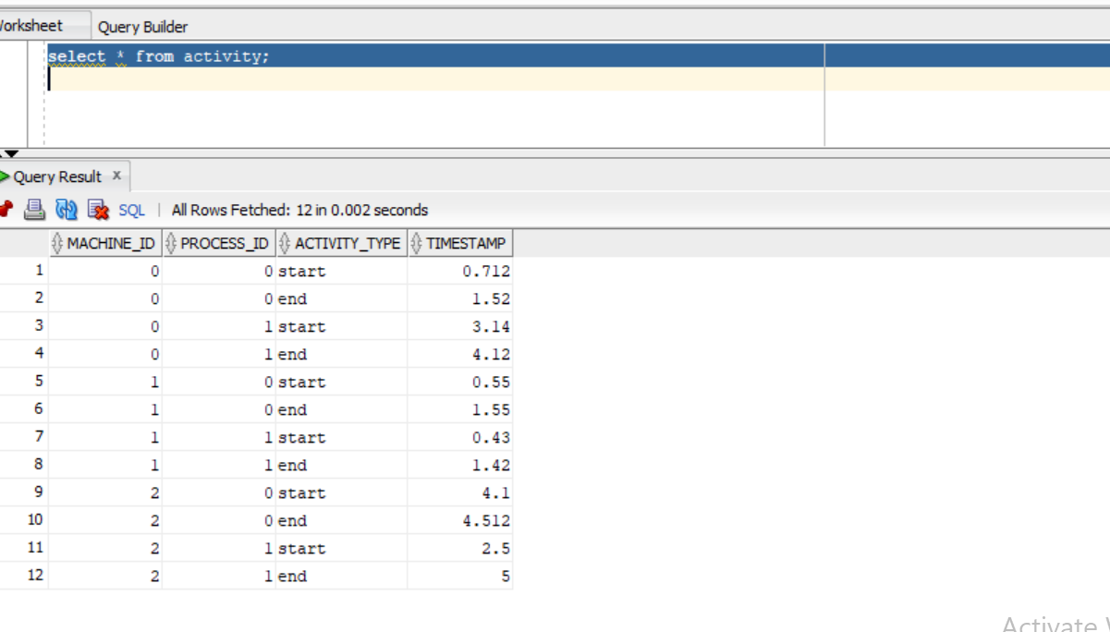

My data looks like this but to begin I want my data columns as machine_id,process_id,start_time,end_time ,so I write the following query.

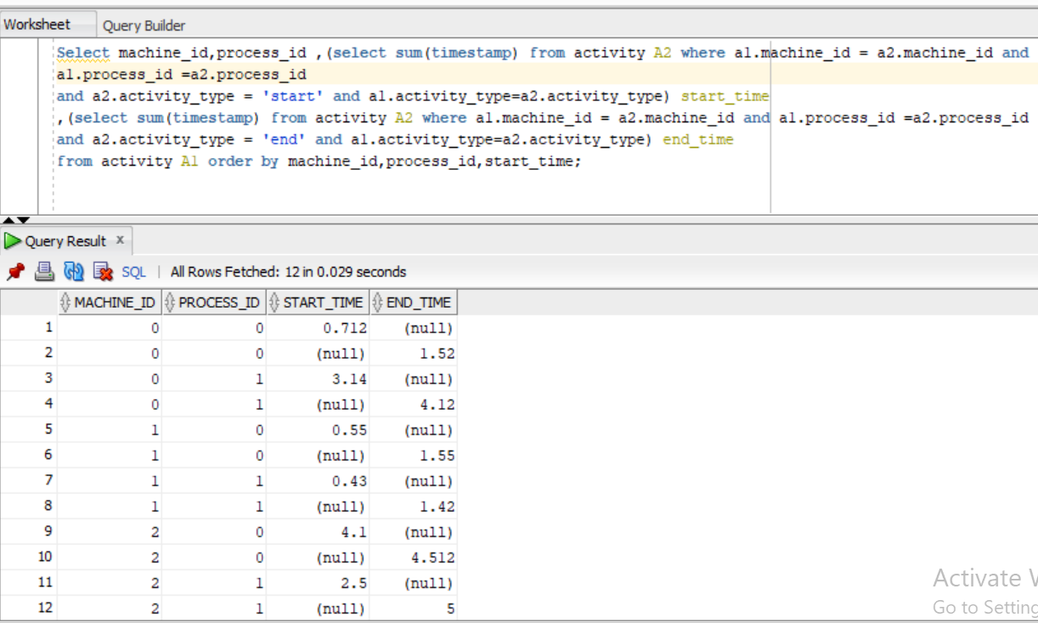

Now I have the required table. I will use this in CTE . I will name my table as newTable

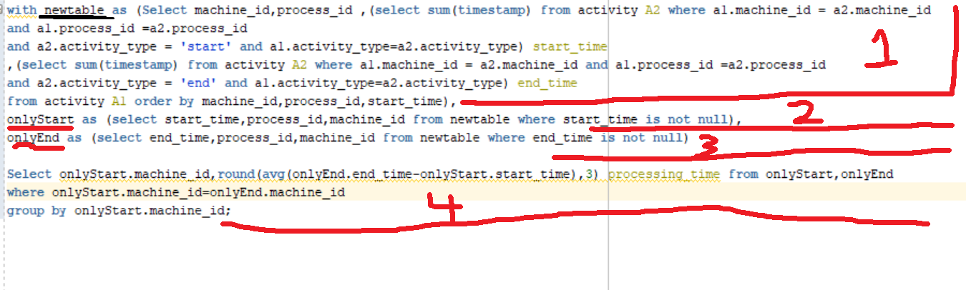

Now I want all the records in one table where only start dates is there with no null values and one table where I have only end dates with no null values. I have taken machine_id also to later use it to join both OnlyStart (2) table and OnlyEnd (3) table.

At last (4) I have grouped the query by machine id by taking machine_id, average and round of difference of onlyStart.start_time and OnlyEnd.end_time , joining both tables on machine_id.

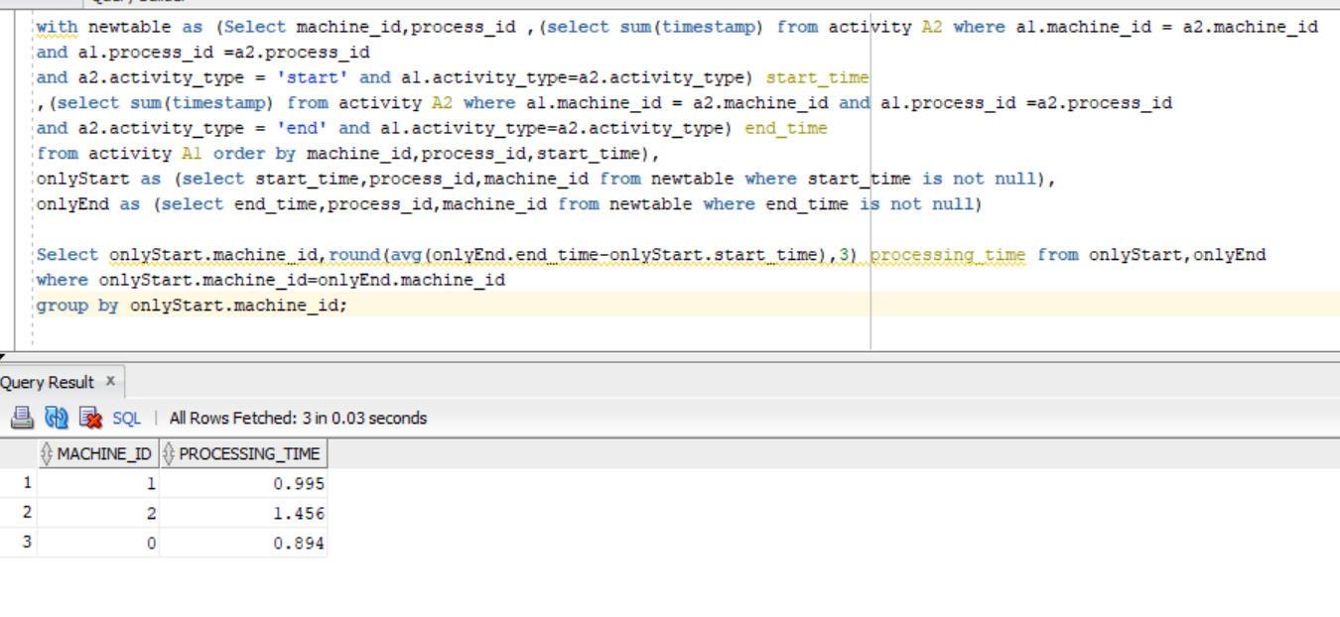

And got the desired result